Assignment 3 and 4
Android App Development
android-project/ at master · nimra-sajid04/android-project

Submitted By: Nimra Sajid
Registration Number: 23-arid-846
Section: BSSE 5B
Github URL: https://github.com/nimra-sajid04/android-project/tree/master

Submitted To: Sir Azhar
Login
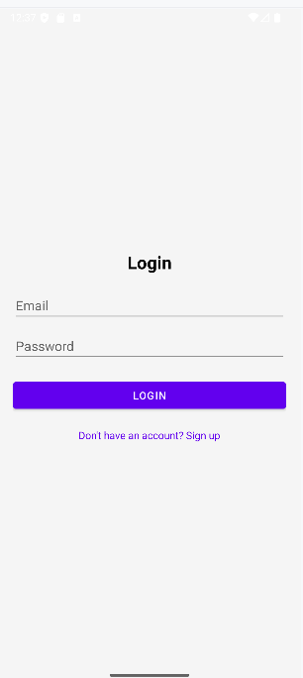

Signup
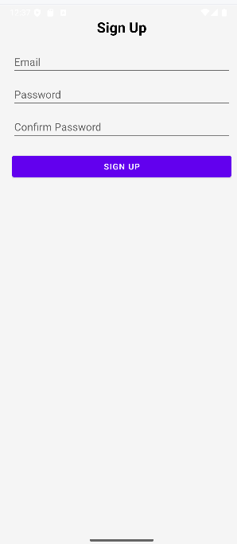

Items
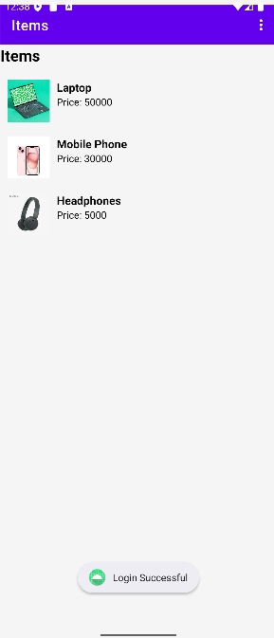

Item Details


Place Order
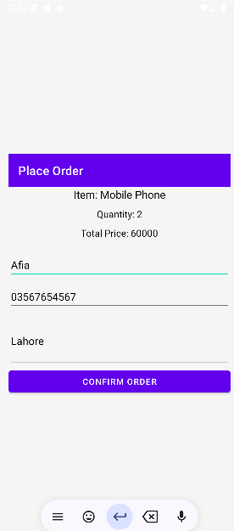

Orders
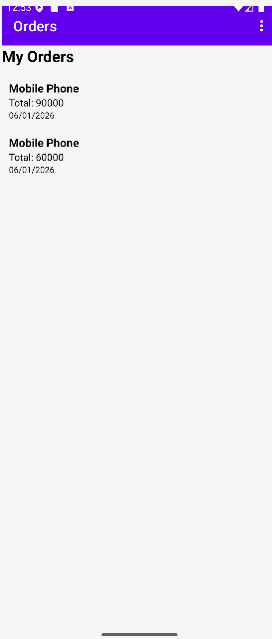

Order Details
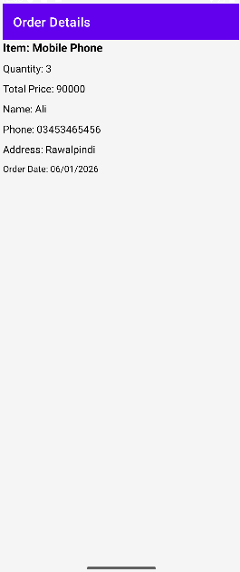

Delete Item
